|  |  |
| --- | --- |
|  | **International Best Practices Analysis Department** |

**The monitoring was produced by a team of experts of the Gaidar Institute for Economic Policy (Gaidar Institute)**:

*Antonina Levashenko,* Senior Researcher, International Best Practices Analysis Department, Gaidar Institute.

*Maris Girich,* Researcher, International Best Practices Analysis Department, Gaidar Institute.

*Ivan Ermokhin,* Researcher, International Best Practices Analysis Department, Gaidar Institute.

*O. Magomedova,* Researcher, International Best Practices Analysis Department, Gaidar Institute.

*Tatiana Malinina,* Senior Researcher, International Best Practices Analysis Department, Gaidar Institute

*The reference to this publication is mandatory if you intend to use this material in whole or in part.*

**International regulation of deepfakes, quantum technologies and the use of artificial intelligence technologies in labor relations**

*Monitoring No. 2 (February 2024)*

March 10, 2024

**Monitoring of international legal regulation trends for the development of legislation in the digital economy in Russia**

*“Our generation believed in the idea of progress...and the materialists have trimmed it, downgrading it to the idea of technological progress”*

*Maxim Gorky*

In February 2024, we can identify 3 events that define trends in the digital economy regulation development

**Trend No. 1. Deepfakes regulation**

In Russia, in February of this year, the Ministry of Internal Affairs, the Ministry of Digital Technology, Communication and Mass Media and Roskomnadzor announced[1] the need for stricter regulation of deepfake technologies: inclusion of the AI use in the perpetration of crimes[2] in the list of aggravating circumstances, prohibiting deepfakes and establishing liability for illegal voice synthesis. In the United States, in the same month, several bills were put forward at the federal and state levels to prohibit the generation of deepfakes on behalf of government agencies and businesses, as well as to prohibit the creation and distribution of a sexually explicit deepfake of an individual without the individual's consent.

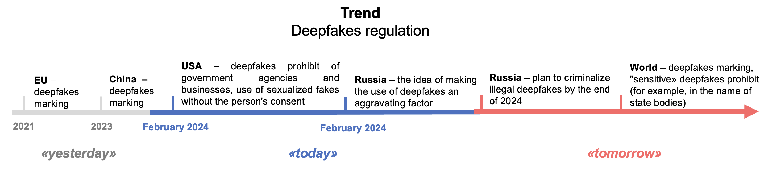

**Trend No. 2. Protection of workers' rights in cases of AI use**

The USA is one of the first countries where plans are underway to regulate the use of AI technologies in making decisions regarding employees. In February, such bills were considered in the state senates of New Jersey, New York, Massachusetts, and Illinois. Other countries have not yet issued similar regulation. Today, such software products based on machine learning, AI, and big data analytics can make decisions regarding a worker's employment, as well as regulate employee labor relations (promotion, termination). The idea is to oblige employers to warn employees or candidates for employment about the use of such technologies, to explain how it works.

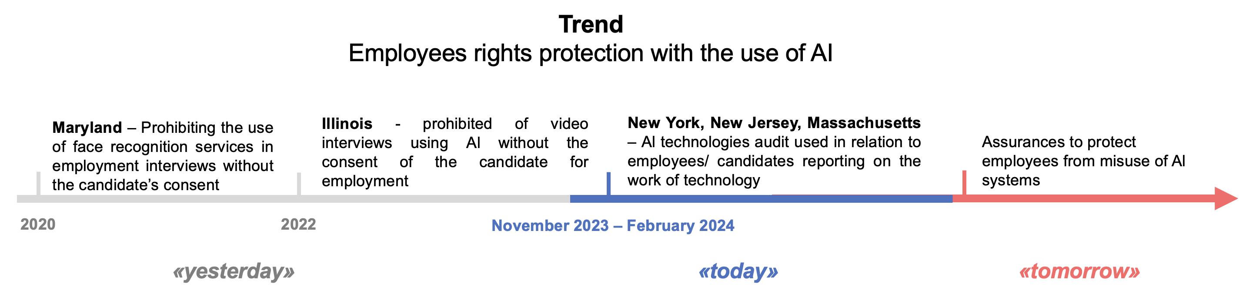

**Trend No. 3. Quantum technologies regulation**

In February 2024, the list of countries that have set for themselves the task of regulating quantum technologies was supplemented by one more state. Since the end of 2010, countries around the world have set the task of supporting the development of quantum technologies. For the digital economy, quantum technologies offer opportunities for exponential growth in cybersecurity and machine learning, as well as for optimizing processes in various industries. The US (2018), China and Russia (2023) have adopted policy documents for the development of quantum technologies, but not laws. In February 2024, the UK joined the ranks of countries that have expressed willingness to regulate quantum technologies. Due to the increasing number of countries developing quantum technologies, there is a demand for the development of international rules and standards in this area, including for the purpose of cross-border use of quantum technologies.

It is important that the measures currently adopted by most countries are mainly aimed at accelerating development rather than addressing the risks posed by quantum technologies. This means that at the present stage the issues of leadership in this area have priority over the creation of legislation. Attention is paid to standardization in the field of quantum technologies. Thus, countries recognize the need to unify the conceptual apparatus and requirements for hardware and software used in this field.

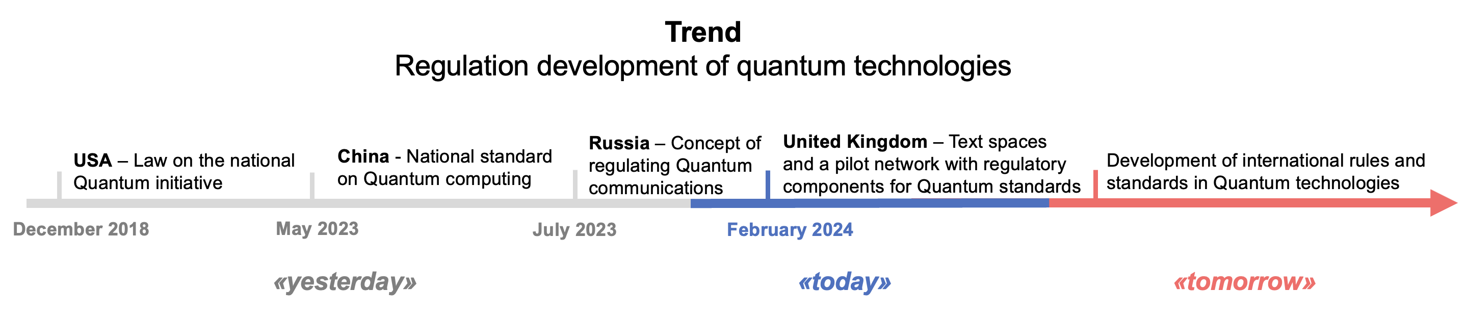

** Key aspects**

**1. Deepfakes regulation**

**The experience of US, EU and China**

Deepfakes are artificially representations of a person's image, speech, or behavior created by technology (AI or other) (OECD).[3]

In February, a few bills were introduced to regulate deepfakes. The U.S. Federal Trade Commission proposed a prohibit on the distribution of deepfakes on behalf of government or business (Impersonation Rule). A little earlier 2 more bills were introduced - No AI Fraud Act (intellectual rights of individuals to their own image and voice; obligation of third parties who want to make digital copies of the image or voice of this person, to take his consent), DEFIANCE Act (prohibiting the creation and distribution of sexualized deepfakes without the permission of the person).

According to the countries' approach, the concept of “deepfake” contains the following features:

1. Represent imitation of people (China, USA, EU) and can also be used to create any fake news (China).
2. Images or sounds are not actually authentic, for example, containing an image or voice of a person saying or doing something they did not actually say or do.
3. Imitation is so realistic that it may appear to a reasonable person to be true or genuine.

At the same time, in accordance with the approach of China, the EU and Russia, deepfakes are created by means of AI, including machine learning. US lawmakers are expanding the approach - a deepfake can be created not only by means of AI, but also with the help of any other technology (e.g., quantum computing, metadata analysis technology) and software.

**Russia’s experience**

In February of this year, the Ministry of Internal Affairs, the Ministry of Digital Technology, Communication and Mass Media and Roskomnadzor stated[4] that they were working on the legal regulation of deepfake technologies. This being said, a month earlier, amendments on criminal liability for the use, transfer, collection and storage of personal data obtained illegally and for the creation of information resources that disseminate them - Article 272.1 of the Criminal Code of the Russian Federation - were adopted in the first reading.[5]

Today, the following approaches to regulating deepfakes have been introduced:

1) Inclusion of the AI products use in the list of aggravating circumstances (Article 63 of the Criminal Code of the Russian Federation) in the perpetration of crimes.[6]

2) Prohibit on deepfakes and liability for illegal voice synthesis.

The Russian approach is to prohibit the use of deepfakes, while the approach in the EU and China is to label deepfakes so that users can differentiate between deepfakes and true information. The United States prohibits the creation of non-consensual sexualized deepfakes and deepfakes on behalf of government agencies, but deepfakes can be created and disseminated if a person consents.

**2. Protecting workers' rights while using AI**

**The US experience**

In the US, there have been a number of lawsuits in the last few years related to discrimination against employees due to the use of AI solutions. For example, in 2022, iTutorGroup was found to have violated the Age Discrimination Act in the US: its AI-based recruitment software rejected more than 200 older applicants. As a result, the company paid $365,000 to candidates who were rejected because of their age.

That is why the trend of regulating the use of AI and related technologies in automated employment decision tools is rapidly developing in the United States. As of this February, such bills were being debated in the U.S. Senate in New Jersey[7] and New York, in Massachusetts,[8][9] and in Illinois.[10]

Regulation is centered on the use of an Automated employment decision tool (AED). The AED tool is based on AI and related technologies. The tool automatically filters potential candidates for employment or regulates labor relations with employees.

The main regulatory goals are (1) to prevent workplace discrimination in the AI use and related technologies; (2) to ensure human control over AED tools and its solutions; and (3) to ensure transparency and understanding of the operation of AED tools.

The following areas that are emphasized in the regulatory framework can be highlighted:

1) Mandatory notification to the candidate/employee that the AED tool is being used.

2) Prohibiting or restricting the technology use that can read emotions or analyze human behavior.

3) Imposing human control over the generated decisions. For example, in Massachusetts, an employer cannot rely entirely on decisions generated by the AED tool, especially when determining employee wages and deciding whether to hire, promote, terminate, or discipline employees.

4) Conducting an annual audit of AED tools. Such audit is aimed at preventing discrimination of employees, including age, race, etc., and at identifying errors, deviations, violations of employees' rights.

5) Introducing special regulation for employers who ask candidates for employment to record video interviews and analyze such videos with AI or use facial recognition services.

**Russia’s experience**

Currently Russia lacks regulation of AI in hiring, although similar technologies are common in the country (e.g., using a robotic recruiter (“Vera”).

In Russia, it may be recommended to supplement the Labor Code (197-FZ) Article 22.4, securing the right of an employee or candidate for employment to know that the employer uses automated decision-making tools based on AI or other similar technologies, to establish a prohibit on the use of such technologies for the purpose of discrimination against an employee or for purposes unrelated to labor. An audit of automated technologies is also important.

**3. Development of the quantum technologies regulation**

Back in early 2022, WEF highlighted the risks of employing quantum computing:[11]

1. The absence of the liable party for actions in connection with the procedures of transformation/change or control in the development or implementation of quantum computing technologies.

2. Security risks:

* Validation or authorization mechanisms based on existing cryptographic techniques, e.g. electronic signatures can be broken by quantum technologies.
* Destabilization of critical infrastructure management protocols, including those based on blockchain technology.
* privacy risks, data governance, etc.

3. Personal data risks:

* Cyber threats from quantum computers to personal data not protected by quantum-safe cryptography.
* Using powerful analytics algorithms to predict or extract information without consent or authorization from datasets containing personal data, including by combining quantum computers with other technologies like AI.

4. Risk in intellectual property regulation: what tools (patent, copyright) and what elements of technology are protected, for what periods of time the protection covers.[12]

However, the regulation of quantum technologies in the countries of the world has taken a different path: its main task is not to reduce these risks, but to accelerate the development of quantum technologies, including through standardization.

**The UK’s experience**

In February, the UK became another country that expressed willingness to develop regulation of quantum technologies, but not to close the risks that WEF[13] talks about. Earlier, the US passed the National Quantum Initiative Act (No. 115-368),[14] which set a goal of developing quantum research and standardization in the quantum field, including cybersecurity and data protection issues. In China, another country claiming leadership in the field of quantum technologies, the world's first national standard “Quantum Computing - Terminology and Definitions” will come into force in 2023. Thus, both China and the US focused not on the risks and challenges of the technology, but on the standardization of concepts used in the quantum industry to accelerate its development. The UK supported this trend. В феврале Великобритания стала еще одной страной, которая выразила готовность к разработке регулирования квантовых технологий, но не закрытия рисков, о которых говорит *WEF*.

The following recommendations are made in relation to regulation in the UK:

1) Creation of testbeds and sandboxes that include regulatory components to identify and implement measures to mitigate the security challenges posed by quantum computers in the cryptography industry.

2) Launch of the UK Quantum Standards Pilot Network, including for standardization of quantum communications, including compatibility standards.

**Russia’s experience**

In July 2023, Russia approved the Concept of Quantum Communications Industry Regulation through 2030 to define the main approaches to regulatory regulation of the quantum communications industry, including quantum cryptography. It is planned to develop information security standards; national standards regulating uniform requirements for equipment, software and methods of their testing; consolidation of the conceptual structure of the quantum communications industry; research in the framework of experimental legal regimes in the field of digital innovations. Thus, at the current stage of quantum technologies regulation development Russian practice is in line with global trends.

1. <https://www.vedomosti.ru/technology/articles/2024/02/16/1020587-mintsifri-s-mvd-i-roskomnadzorom-opredelyat-nakazanie-za-dipfeiki>
2. <https://pravo.ru/news/251582/>
3. https://oecd.ai/en/incidents/58608
4. <https://www.vedomosti.ru/technology/articles/2024/02/16/1020587-mintsifri-s-mvd-i-roskomnadzorom-opredelyat-nakazanie-za-dipfeiki>
5. <https://sozd.duma.gov.ru/bill/502113-8#bh_note>
6. <https://pravo.ru/news/251582/>
7. <https://www.njleg.state.nj.us/bill-search/2024/S1588/bill-text?f=S2000&n=1588_I1>
8. <https://www.nysenate.gov/node/12029882>
9. <https://legislation.nysenate.gov/pdf/bills/2023/s7623a>
10. <https://malegislature.gov/Bills/193/H1873>
11. Quantum Computing Governance Príncipes. Insight report. World Economic Forum. January 2022. – https://www3.weforum.org/docs/WEF_Quantum_Computing_2022.pdf.
12. https://www.allenovery.com/en-gb/global/news-and-insights/publications/the-opportunities-and-legal-risks-of-quantum-computing.
13. https://www.gov.uk/government/publications/regulatory-horizons-council-regulating-quantum-technology-applications.
14. https://www.congress.gov/bill/115th-congress/house-bill/6227/text.